SAMEDAY EXPRESS
ADDITIONS WEB POD PORTAL

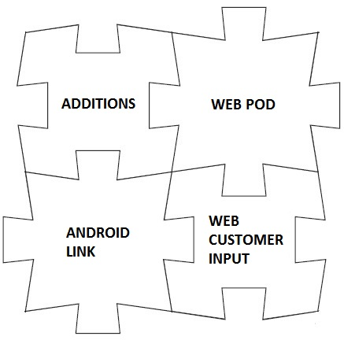

ZiPZAP Computers Limited
Unit C2 The Point
Weaver Road
Lincoln
Lincs
LN6 3QN

www.zipzap.co.uk

‘ADDITIONS’ for Sameday Express - copyright ZiPZAP Computers Limited

This is a walkthrough document to cover concept and installation.

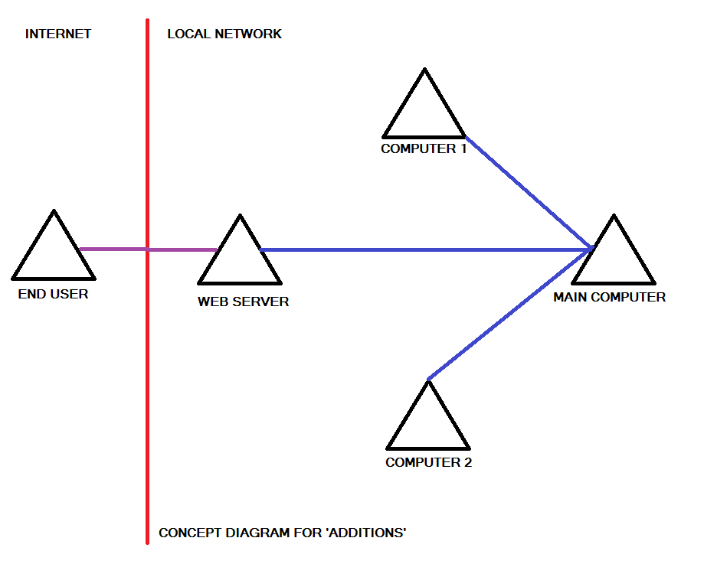

You will need a computer that can operate as a web server. Windows 7 and 8 is perfectly acceptable as it is already built-in, but normally just turned off.

In this example the datafiles for Sameday Express are held on the MAIN COMPUTER on its local C: drive called SDATA. This directory is mapped by the three other computers as an S: drive. All the computers have Sameday Express loaded and can all see the data. Your will be different but the idea is the same.

You now need to set up IIS (Internet Information Server) on the WEB SERVER. IIS is just a standard web server and in reality any web server could be used that supports PHP.

Go into Control Panel

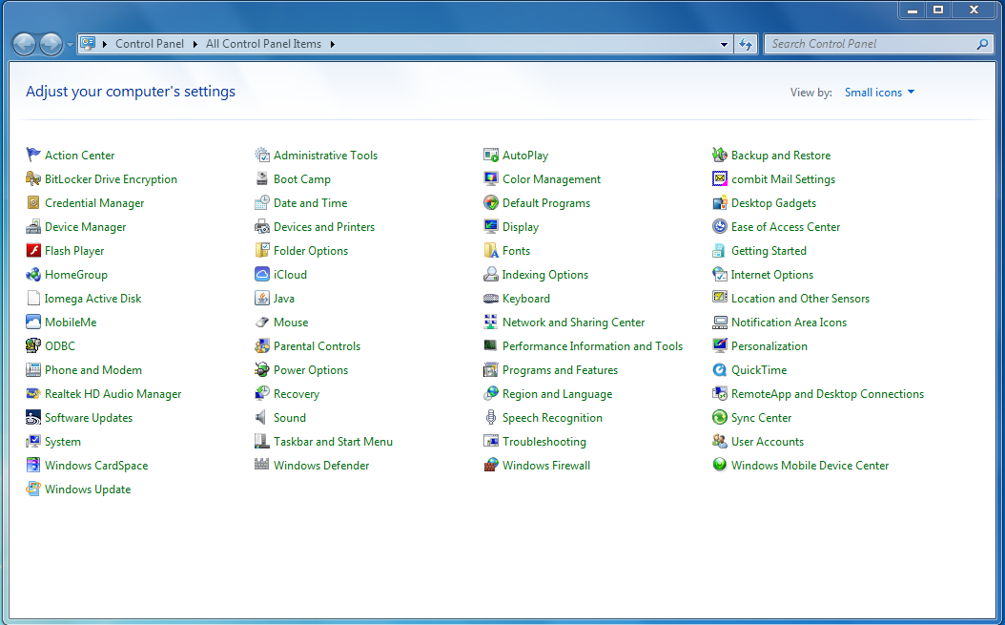

Click on Administrative Tools

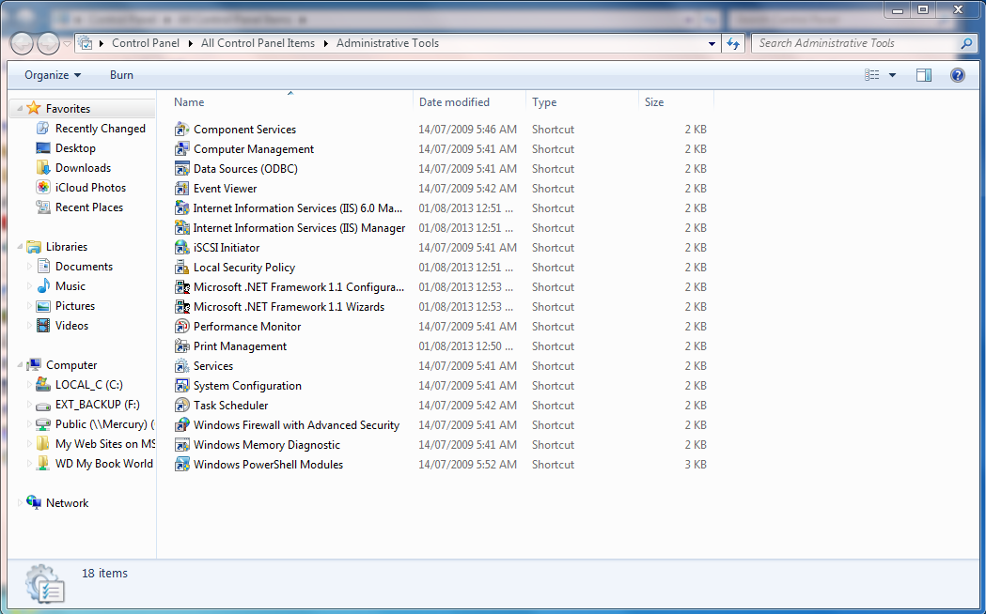
Click on Data Sources (ODBC)

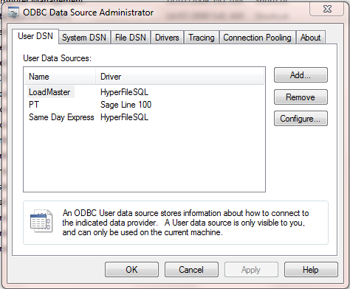

You will see items in here already. Click on System DSN

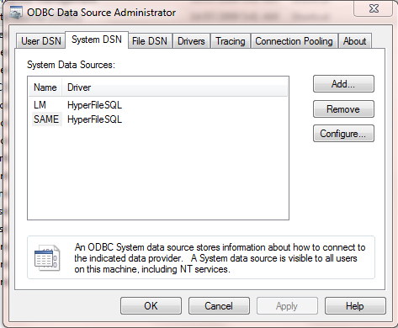

The above will be empty. Click on Add. Choose HyperfileSQL. Then set up as below.

Note that the full name of the Analysis will be different. It should be in C:\Program Files\Same Day Express\ or similar.
Just choose the file using [...] option. It is the only file with a .WDD extension.

The directory of files will be the data directory on your server. It will appear as the data directory within the local program.

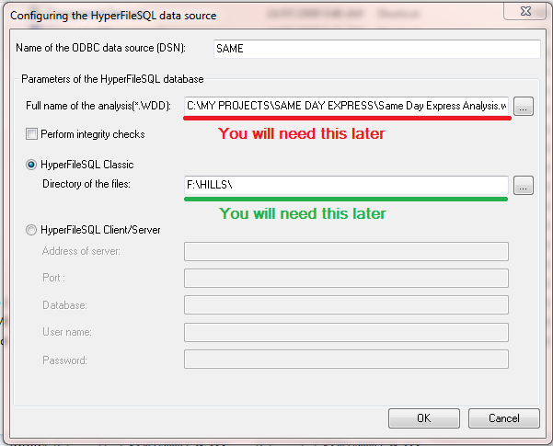

Make a note of these values. It will be used later. Using my original example this would be S:\SDATA

In Control Panel go into the option of Programs and Features.

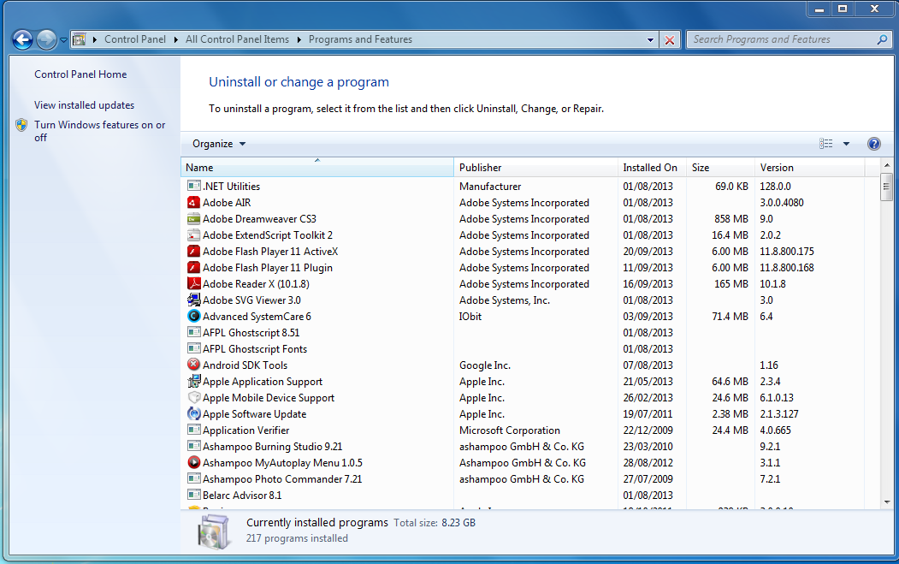

Click on the option of Turn Windows features on or off. Go to Internet Information Services and open the option.

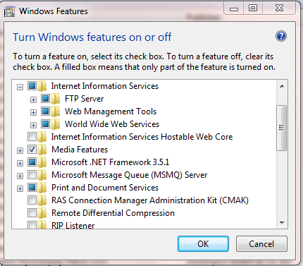

Click on the Management Tools sub-menu.
Turn these options ON.

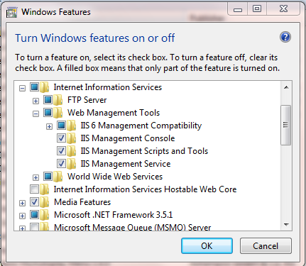

Then into the World Wide Web Services option.

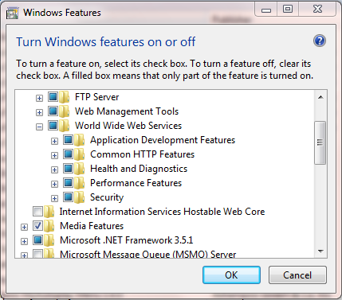

Turn these features ON.

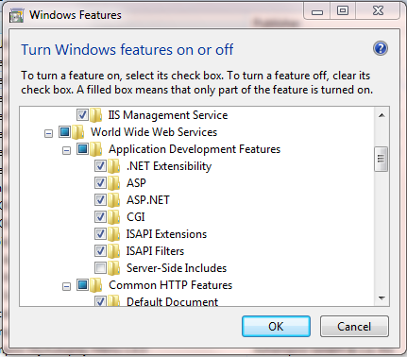

And these.

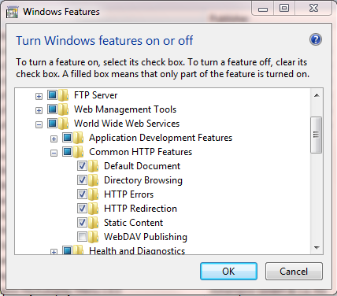

And these.

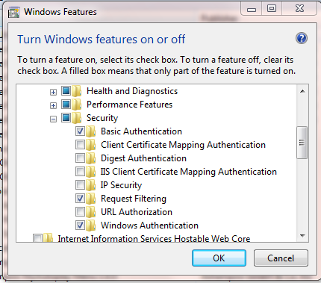

Save all.

Now go into Internet Explorer and type 127.0.0.1 on the address line. You should see this -


In Internet Explorer go to http://php.iis.net/

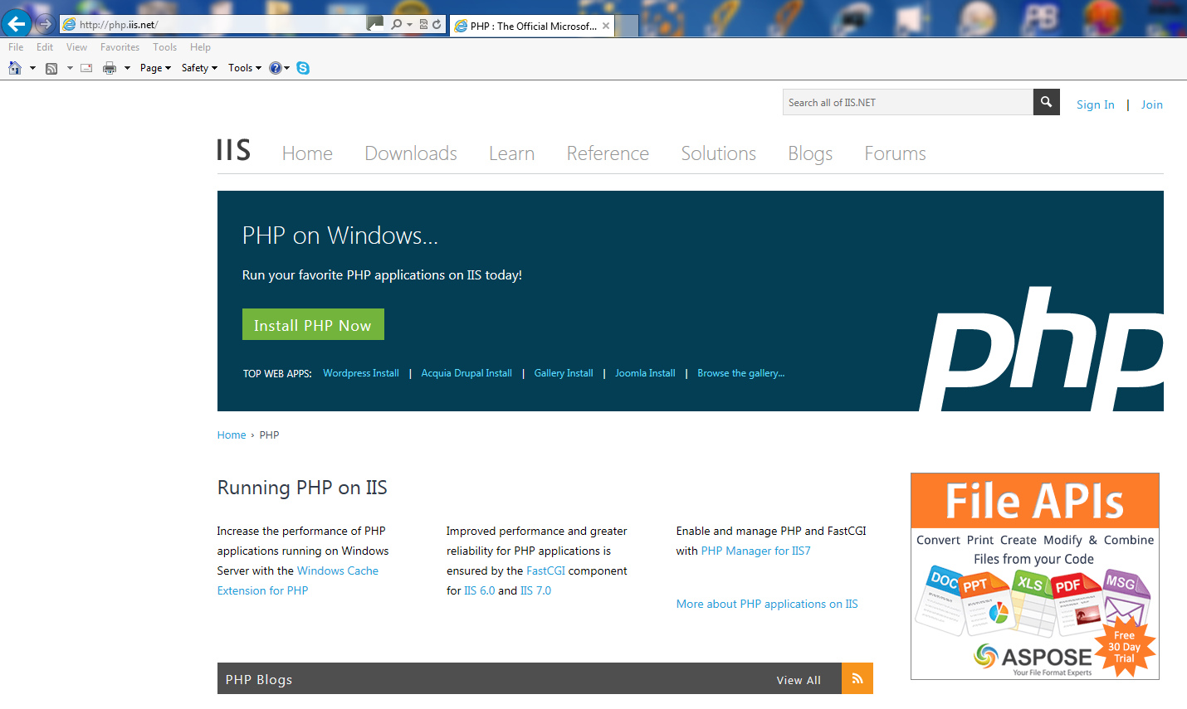

Click on the Install PHP Now button. Let this load. Go into Explorer and click on local disk C:

You should see something like this -

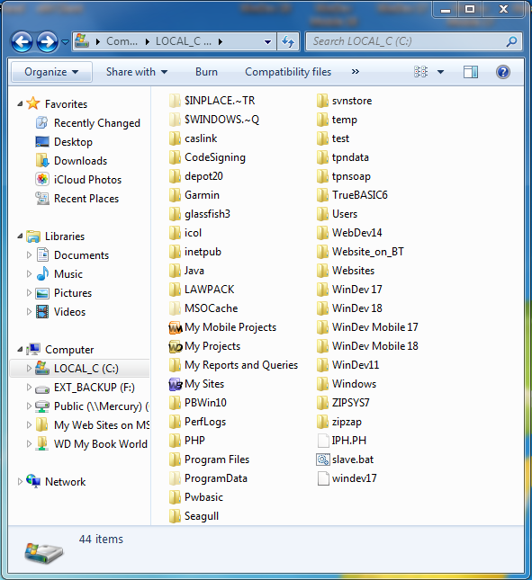

Click on Inetpub and then wwwroot

Copy the files we sent into this location.

This will be similar (but not the same) as this -

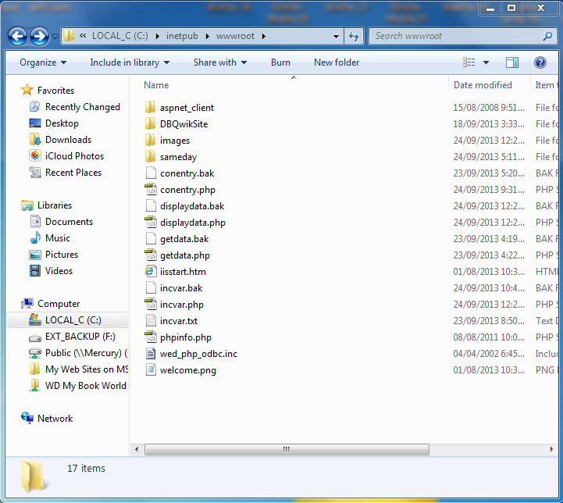

Right-click incvar.php and open in Notepad (choose ALL FILES)

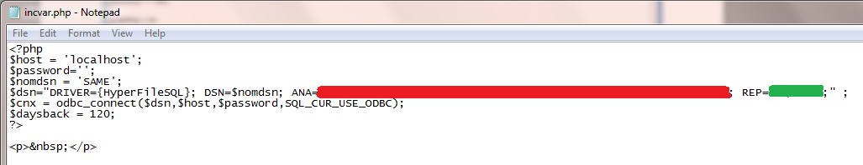

Amend the values shown in red and green to those from the ODBC connection that you saw earlier.

Save.

Go into Internet Explorer and type 127.0.0.1/phpinfo.php on the address line. You should see a screen full of information and not an error.

In Sameday Express pick an account and go into setup/accounts. Go to the web tab. Enter a unique username and password.

Go into Internet Explorer and type 127.0.0.1/getdata.php and you should get a screen asking for a username and password. Enter those you created and click on the Access button. You should now see the data from your program.

To get this visible to the outside world you need -

1. either need a fixed IP address or a dynamically assigned address using something like dyndns (so you end up with something like mysite.dyndns.org that goes directly to the web server).
2. on your router fix the internal IP address of the web server e.g. 192.168.1.10 or similar
3. on your router allow inbound data on Port 80 and redirect to the web server computer
4. on your web site place a link for your customers to the web server

Our test page is at http://zipzapzeus.dyndns.org/SAME/getdata.php

Web pages supplied -

getdata.php
displaydata.php
incvar.php
phpinfo.php

